Test Case: runTestMultipleTimes
Step 1 - Enter username and password and click to button Enter : Credentials Entered
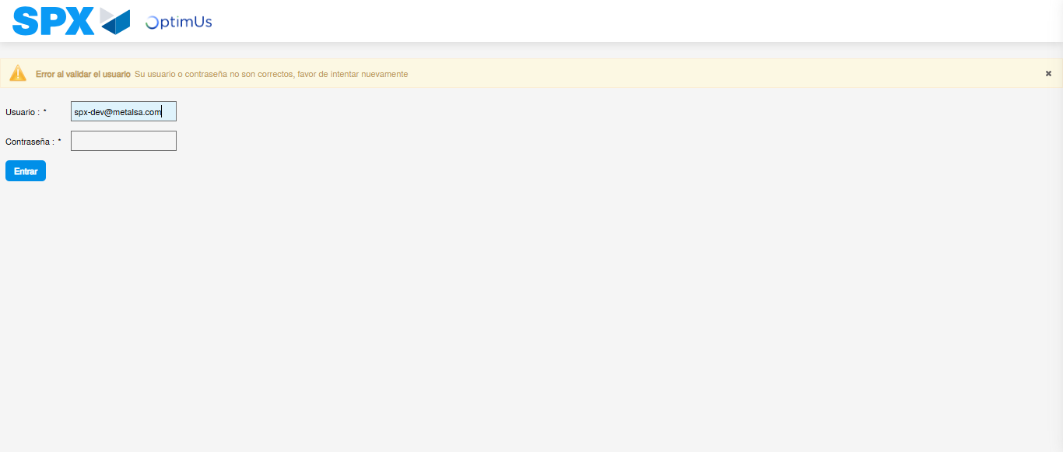Image file-name: QC_Testing-runTestMultipleTimes-nov. 20 2025, 02 21 09 p. m.

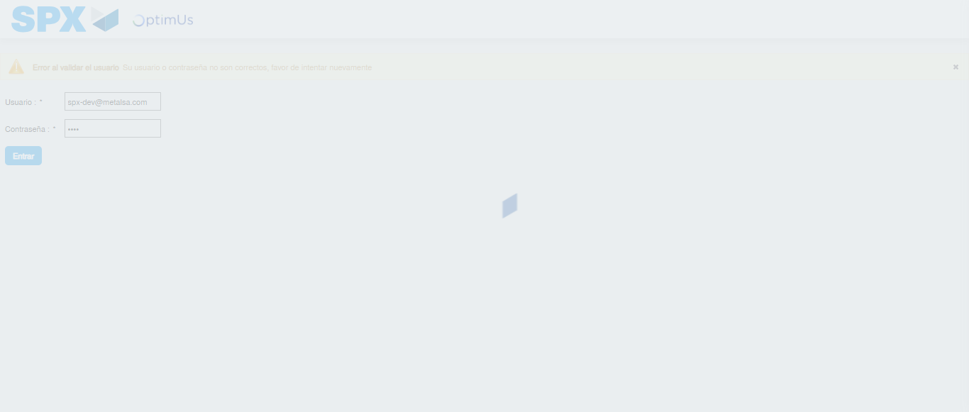Image file-name: QC_Testing-runTestMultipleTimes-nov. 20 2025, 02 21 10 p. m.

Step 2 - Select to UEN and Access to Administrador Roles Menu: UEN Correctly selected and Correct access
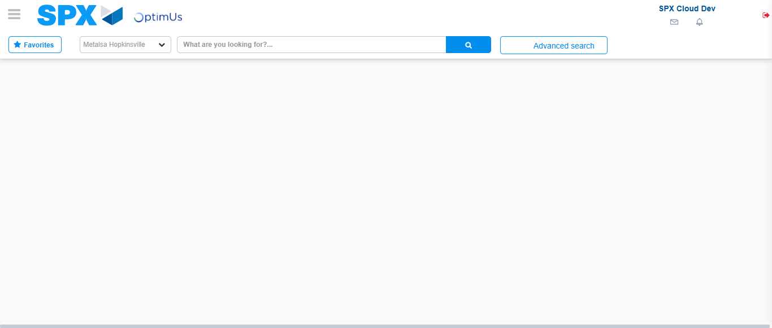Image file-name: QC_Testing-runTestMultipleTimes-nov. 20 2025, 02 21 13 p. m.

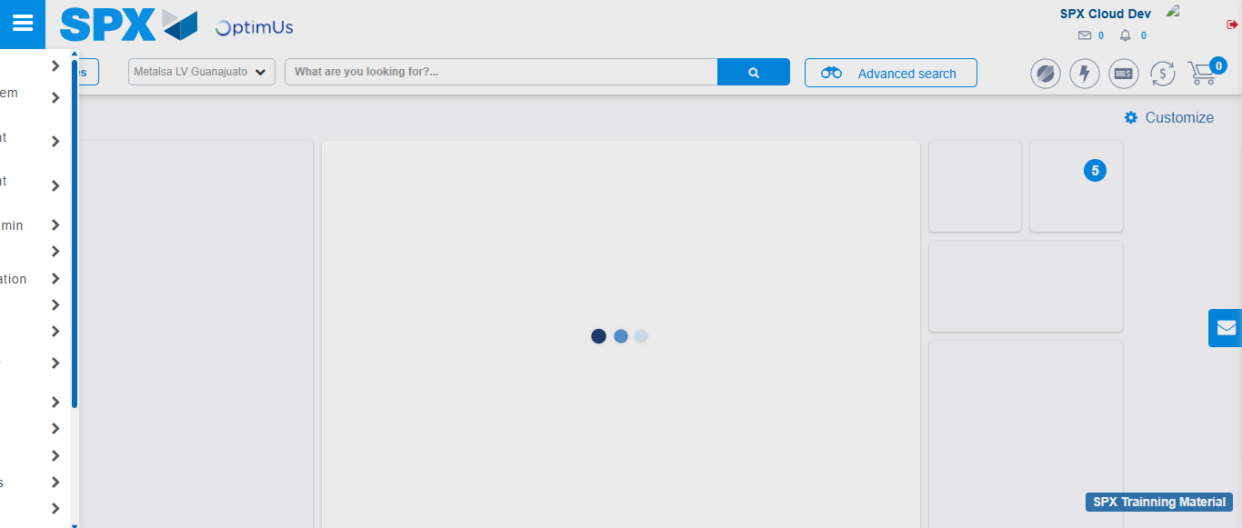Image file-name: QC_Testing-runTestMultipleTimes-nov. 20 2025, 02 21 14 p. m.

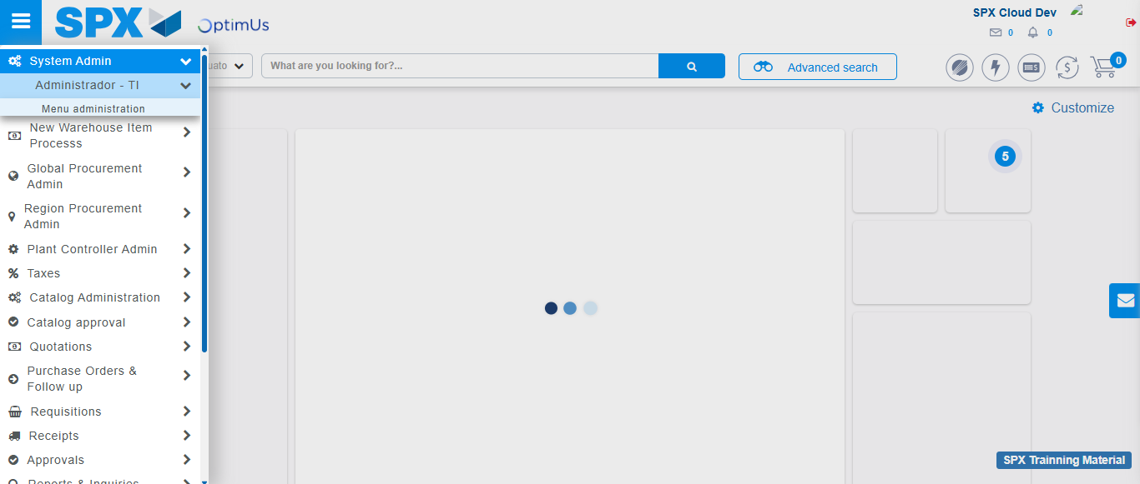Image file-name: QC_Testing-runTestMultipleTimes-nov. 20 2025, 02 21 15 p. m.

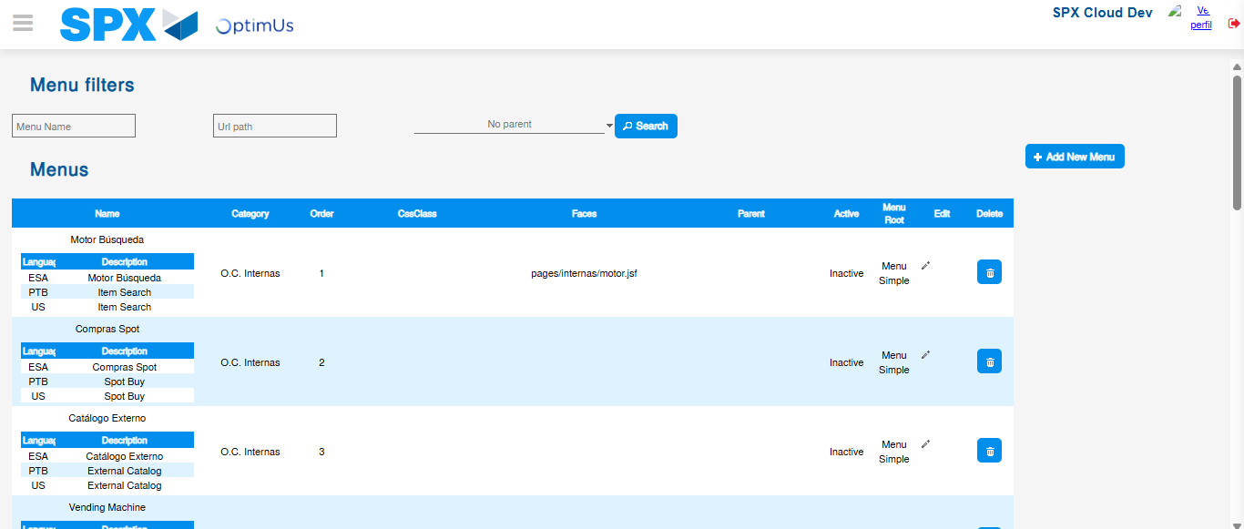Image file-name: QC_Testing-runTestMultipleTimes-nov. 20 2025, 02 21 20 p. m.

Step 3 - Delete record: Record successfully deleted
Image file-name: QC_Testing-runTestMultipleTimes-nov. 20 2025, 02 21 20 p. m.

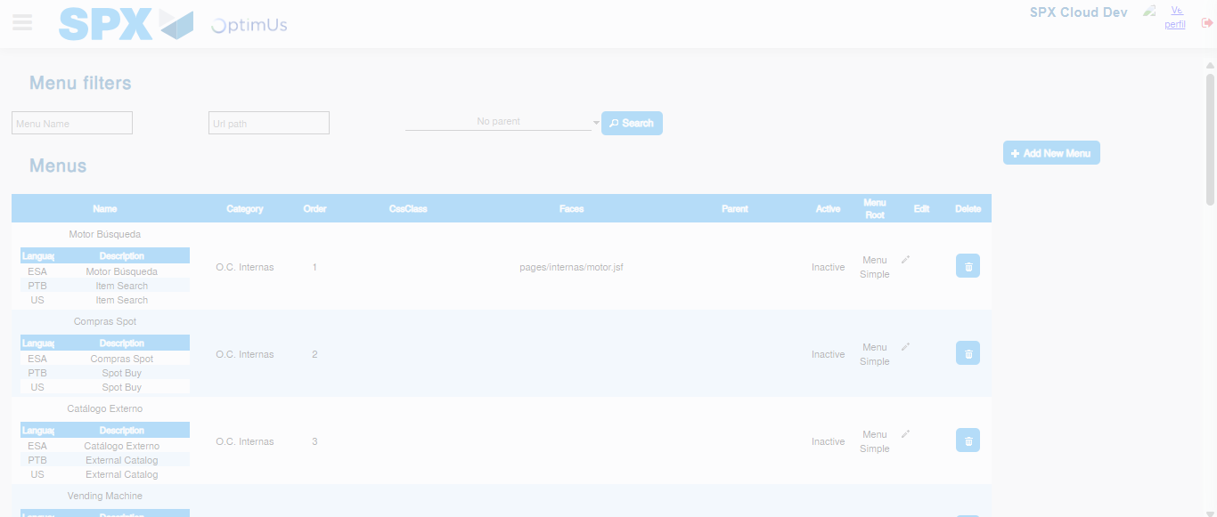Image file-name: QC_Testing-runTestMultipleTimes-nov. 20 2025, 02 21 21 p. m.

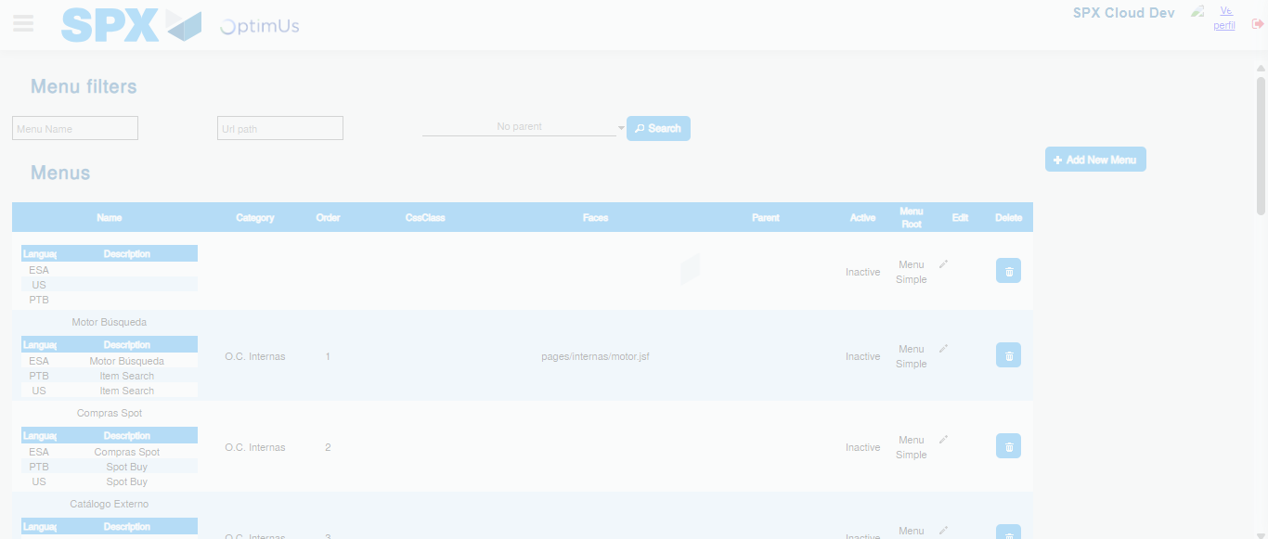Image file-name: QC_Testing-runTestMultipleTimes-nov. 20 2025, 02 21 24 p. m.

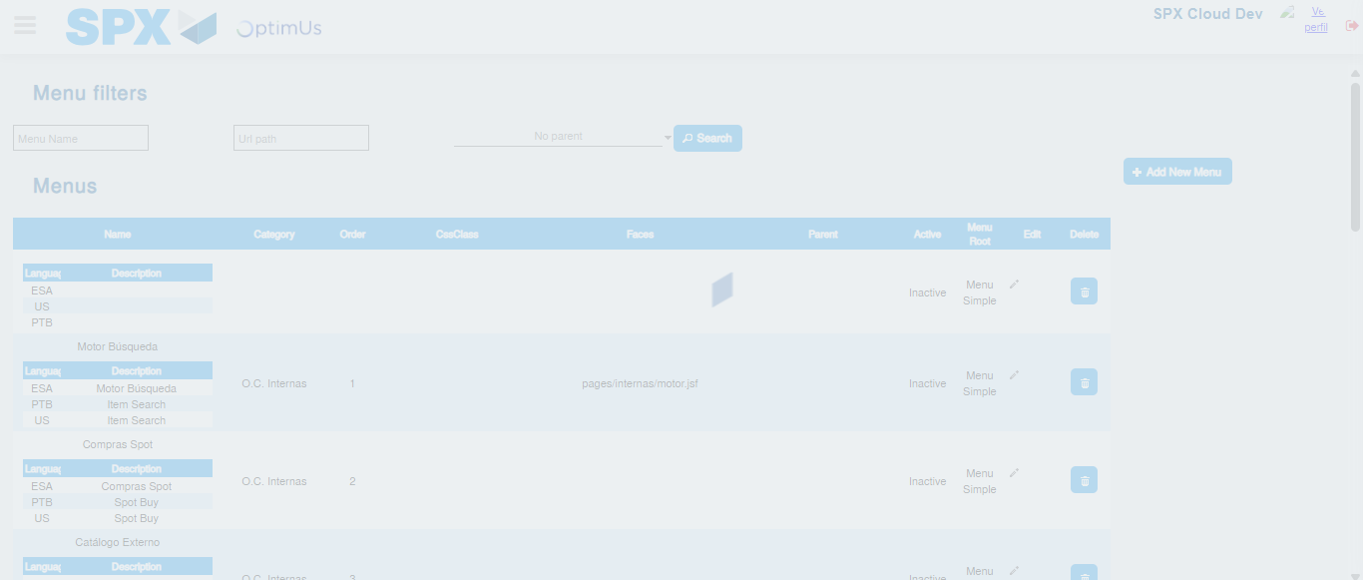Image file-name: QC_Testing-runTestMultipleTimes-nov. 20 2025, 02 21 25 p. m.

